Web-Based Wallet
# Source: AI Source: Provided by: [Data Path: Persons Table -> ID Column: 1, Name_En Column: Motasem Essam] -> From: [ChatGPT] on [1/21/2026]
A Web-based wallet is a digital wallet accessed through a web browser, allowing users to store and manage digital money or assets online without the need to install a mobile app or desktop software. It operates entirely via the internet and is typically hosted on a third-party server.

✅ Key Characteristics of Web-Based Wallets:
# Source: AI Source: Provided by: [Data Path: Persons Table -> ID Column: 1, Name_En Column: Motasem Essam] -> From: [ChatGPT] on [1/21/2026]
- Access via Browser
  - Accessible from any device (PC, tablet, phone) with an internet connection and a browser.
- Cloud-Hosted
  - Wallet data (including balance and transaction history) is stored on remote servers.
- Username/Password Login
  - Usually secured by account credentials, 2FA (two-factor authentication), or biometric extensions.
- Supports Digital Assets or Fiat
  - Can store traditional currency (e.g., USD, EUR), cryptocurrencies (e.g., Bitcoin), or loyalty points.
- Device-Independent
  - Doesn’t require local installation or mobile-specific access.

🔄 Examples of Web-Based Wallets:
# Source: AI Source: Provided by: [Data Path: Persons Table -> ID Column: 1, Name_En Column: Motasem Essam] -> From: [ChatGPT] on [1/21/2026]
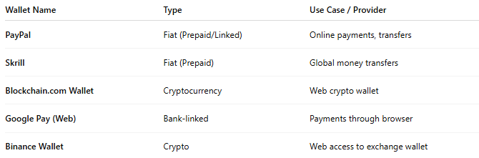

Wallet Name | Type | Use Case / Provider
PayPal | Fiat (Prepaid/Linked) | Online payments, transfers
Skrill | Fiat (Prepaid) | Global money transfers
Blockchain.com Wallet | Cryptocurrency | Web crypto wallet
Google Pay (Web) | Bank-linked | Payments through browser
Binance Wallet | Crypto | Web access to exchange wallet

🛠️ How It Works:
# Source: AI Source: Provided by: [Data Path: Persons Table -> ID Column: 1, Name_En Column: Motasem Essam] -> From: [ChatGPT] on [1/21/2026]
- User creates an account on the wallet provider’s website.
- Wallet is funded via:
  - Bank transfer
  - Credit/debit card
  - Crypto deposit
- User can:
  - Make online purchases
  - Send money to others
  - Withdraw to bank or crypto wallet
- Funds and credentials are stored on the provider's server, not the user's local device.

✅ Advantages:
# Source: AI Source: Provided by: [Data Path: Persons Table -> ID Column: 1, Name_En Column: Motasem Essam] -> From: [ChatGPT] on [1/21/2026]
- Cross-platform access (any OS or device)
- No installation required
- Ideal for online shopping, e-commerce, and trading
- Easy to manage via web dashboard
- Often includes multi-wallet or multi-currency support

⚠️ Risks & Challenges:
# Source: AI Source: Provided by: [Data Path: Persons Table -> ID Column: 1, Name_En Column: Motasem Essam] -> From: [ChatGPT] on [1/21/2026]
- Dependent on internet connection
- Vulnerable to phishing attacks or website spoofing
- Custodial wallets: provider controls your funds unless non-custodial
- Users must trust web security practices of the provider

🆚 Compared with Other Wallet Types:
# Source: AI Source: Provided by: [Data Path: Persons Table -> ID Column: 1, Name_En Column: Motasem Essam] -> From: [ChatGPT] on [1/21/2026]
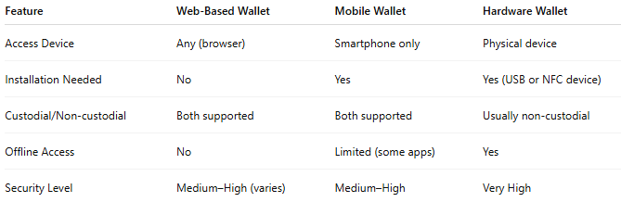

Feature | Web-Based Wallet | Mobile Wallet | Hardware Wallet
Access Device | Any (browser) | Smartphone only | Physical device
Installation Needed | No | Yes | Yes (USB or NFC device)
Custodial/Non-custodial | Both supported | Both supported | Usually non-custodial
Offline Access | No | Limited (some apps) | Yes
Security Level | Medium–High (varies) | Medium–High | Very High

🧠 Best Use Cases:
# Source: AI Source: Provided by: [Data Path: Persons Table -> ID Column: 1, Name_En Column: Motasem Essam] -> From: [ChatGPT] on [1/21/2026]
- E-commerce payments
- Freelancers and international payments
- Crypto trading platforms
- Remittance services
- Users who prefer managing money via desktop/laptop

